Saleo Deal Memo – TSVF II
03/28/2022

Company: | Saleo (https://saleo.io/)
Deal Team: | Scott Lopano, Vasant Kamath
Location: | Atlanta, GA
Source: | Scott – Personal Network
Fund & Allocation: | TSVF II; $1,000,000
Round Terms: | $1.5M round, $9M post-money including [7]% post-money option pool. TSV post-round fully-diluted ownership will be 11.11%.

Overview: Saleo is a demo experience platform, allowing software companies to build custom demos at scale. Saleo’s SaaS platform features a creative story builder, enabling sales engineers to create template demos tailored to industries and prospect types, with live demo data, quickly and without development resources. The Chrome plug-in then enables sales teams to alter the authentic product for each sale situation, and maximize probability of conversion. Lastly, their dashboard becomes the homebase for sales engineers and managers, with all demo analytics, calendars, and insights.
Vision: Each point in the sale process has its own $bn+ company, except for demos. Saleo envisions expanding from sales teams to product marketing, content marketing and customer success, utilized across the revenue focused functions. With a robust dashboard of analytics and insights, along with integrations to key CRMs that drive ROI and attribution, Saleo will be the missing link, a vital part of the sales tech stack.
History: Scott met Justin back in 2018, when he had just stepped in as CEO of RambleChat, to turn the business around, taking their solid AI-driven chat product to market. We passed on the opportunity at the time, given the crowded market and their lack of clarity on target segments / competitive advantage. Justin respected the decisions and kept in touch. He sold the business to Terminus in May 2020 and joined their ELT as GM of conversational marketing. He and Dan met then and started working together, as Dan ran digital marketing at Terminus. Justin reached out in mid-2021 for a call update with Scott, we were tracking it, but it was too early. We reconnected in February 2022 for a demo, to meet the team, and talk about how they’d stand out in the crowded space. The two co-founders have announced they are leaving Terminus to the CEO and board and have navigated toward a supportive / favorable exit. We will need to ensure there are no issues around IP, having been built over a significant period of time at Terminus. They plan to start the business officially in a matter of weeks and be funded by the start of May.
Deal Summary: TSVF II plans to invest $1M in the $1.5M Seed Preferred financing round. The post-money valuation is $9M inclusive of a 7% post-money option pool. TSV’s fully diluted post-round ownership will be ~11.1% (at $9M post).

Thesis:
- Market opportunity:
  - Significant amount of capital in the market, focused on growth, while there’s a shortage for developers. We see the SaaS/software market continuing to grow, along with budgets for sales tools with attributable ROI.
  - We categorize the market from Marketing <> Prod Content <> Tours <> Demos* <> Demo Builders (services) <> Sales - Saleo lives at the demos, vs Tourial at Tours
    - We expect there to be much greater budget closer to sales (closer to attribution), and it relies less on growth of ‘Product Led Growth’ strategies.
- Product: Sophisticated product relative to the market, defendable, and solves a demo problem (can manipulate graphs and data, dashboards, in real-time on real product)
  - Positioning: Solidly positioned in a different market than the many other competitors, focusing on authentic demo environments without the dev resources. Navattic, Reprise, Walnut all focused on selling to marketers and fueling PLG.
- Team: Very strong co-founders, with S&M expertise and relevant startup backgrounds. Balance eachcother well with Justin (sales, big picture) and Dan (marketing, ‘do-er’):
  - Justin McDonald: 12+yrs in SaaS sales and leadership, took over as CEO of conversational marketing bot company, sold to Terminus 2yrs ago, ELT now.
  - Dan Hellerman: Dev background, app builder, Dir of Digital Marketing for SevOne - Bain backed to $1bn valuation. Joined Terminus very early in prod & dig marketing strategy, grown and led the teams there.
- Insight: This team knows the problem and pain point well, having experienced it in Terminus and spending the last ~6 months on customer discovery
  - Our diligence on Tourial, along with extensive market calls, have also supported the pain point and value of customer demos
- Timing: This is an optimal point in time to leverage the existing base of SaaS companies out there, catching it in it’s growth, while not falling behind funded competitors like Reprise and Demostack.

Key Risks:
- Traction: As a very early stage business, there are no historicals or traction to reference.
  - However, Terminus has verbally committed to being a customer at $60k ACV
  - They have a pipeline through their own networks, and the 128 identified SaaS products they are compatible with, to get initial early traction.
- Pricing: Their thesis is this will be an upmarket tool, and more valuable to sales leaders and others, to support a higher price point than Tourial or others in marketing.
  - Our diligence supported possible expansion, but that they’d come in at a similar price point than existing products, which is lower than Saleo’s - unclear on downmarket attractiveness
- Market Size: The number of SaaS / software companies vary widely depending on source, which produces a SAM of anywhere from $600M - $2bn globally, and may be smaller with the downmarket not being a realistic target yet.
  - However averaging sources would suggest a 15% CAGR, resulting a 2X of the market in 5 yrs from 2021, by 2026.

Team:
Justin and Dan have worked together at Terminus for the last 2 years and have gotten to know each other well. They have a good co-founder relationship, witnessed over lunch and calls, fairly balanced. Justin brings the sales background, tactically, but also in his tendency toward vision, speed, and the big picture. Dan balanced Justin with expertise in Marketing and Product and more of a ‘Do-er’ mentality. We’ve watched them release new products over weekends, and work quickly. They built this product over ~9 months, just nights and weekends.

Justin McDonald (Co-Founder, CEO): Justin graduated from Indiana University - Kelley School of Business with a BS in Finance and Economics. Justin worked for Compliance 360, moving from Sales Associate to Director of BD. He then lateraled to SAI Global as Director of BD. After SAI Global, he took over as CEO of RambleChat, a conversational marketing chat product which was acquired by Terminus a few years in. At Terminus, Justin started as GM of Chat, Email & Web before being promoted to GM of Channel Applications and subsequently SVP, GM of Conversational Marketing.
- Seems like a strong sales leader, with 15yrs experience on the sales process and pain points. Ramble gave him experience at startup leadership. Ramble struggled scaling multiple products sold to multiple personas, in multiple industries. At Terminus, he experienced selling a SaaS solution to big accounts, and led teams.
- He has shown some naivete in the fundraising process, regarding finding the ideal partner and understanding of valuations. He hasn’t raised meaningful capital and will need coaching there. In general, he has the ambition, work ethic, and confidence typical of a sales background but also the blindsides associated with that.

Founder References on Justin:
John Hanger (Serial entrepreneur, sold his company ContactAtOnce to LivePerson):
- He has mentored Justin at both RambleChat and Saleo, and did not invest in RambleChat but would be interested in angel investing in Saleo. He believes Justin is intelligent, hungry, and coachable, while acknowledging his salesy-ness, and of good character. He was unsure if Justin had any previous experience with VCs and governance.

Dan Hellerman (Co-Founder and CPO):
- Dan graduated from Penn State University with a Bachelor of Science in Information Systems and Technology. After graduation, he founded Cinefy and worked on it for a number of years before moving to SevOne as the Director of Digital Marketing. After SevOne, Dan lateraled to Terminus as a Senior Director of Digital Strategy and ultimately was promoted to VP of Advertising and Data Platforms. After briefly leaving the company to be the Head of Marketing at Cloudreach, Dan returned to Terminus and was most recently VP of Media Strategy & Architecture.
  - Complements Justin well, a technical leader but also a marketing and advertising leader, also lead many teams, Terminus executive, wants to return to startup world

Founder References on Dan:
- Tonni Bennet (Early at Terminus, worked very closely for years)
- Jon Hallet (Terminus BoD)
  - Both confirmed that he is super high potential, can solve almost any problem. However, can be abrasive and so needs the right team around him

Alexey Svetliakov (Co-Founder):
- Alexey graduated from ITMO University in St. Petersburg, Russia with a Bachelor’s Degree in Computer Science. Initially working as a Software Developer for ABISoft, Alexey moved to work for Teledini as the Lead Software Developer. After leaving Teledini, Alexey joined RambleChat as the Lead Software Developer and continued on, to Terminus, where he is currently a Senior Software Developer.
  - We haven’t met Alexey yet, but he is one of the top developers at Terminus right now, and built the RambleChat product that Justin sold. They’ve worked together for 5yrs. Jon Hallet said ‘he’s gold’.

______________________________________________________________________________________________________________

Solution & Product:
Environment:
Professional Videos | Product Recordings | Tours | Demo Builders | Demo Environments | Customer Experience
Passive, static, expensive, long lead time and quickly outdated | Static, unprofessional and inconsistent, not scalable | Limited, ‘re-produced’ / fake version of product, fixed data, no hover | Difficult to build, often services, can’t manipulate data in real-time | Not scalable, dev resources to spin up new environments for custom demos | Very robust industry, but not built or sold for sales teams

Problem – Demos of the authentic software instance, with live data charts and graphs, and customized text and images, perform the best. Most companies have to resort to ‘zombie’ demos with no data or an irrelevant experience to the prospect, and lose deals. Demo environments are expensive to sustain with dedicated developer resources required for any/every small or big tweak, to achieve customization. There is also no centralized place to extract insights from the demo process. Products that sandbox or snapshot the product severely limit functionality and really serve to front-run demos as marketing products (i.e. tours).

Solution – Customized demos at scale
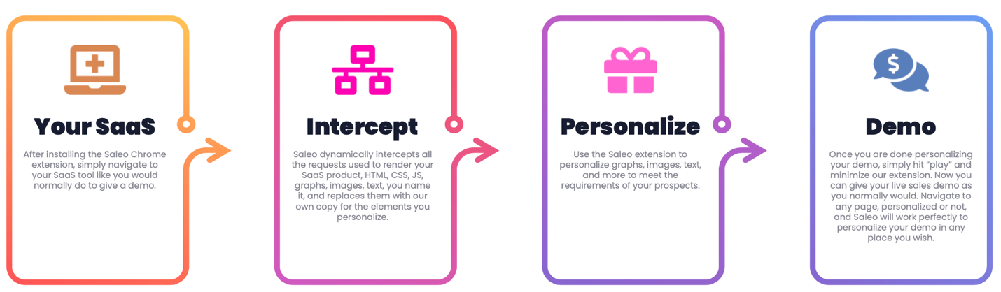
By intercepting the requests as a Chrome plug-in, Saleo simply replaces the data from the products database, with the dummy data of your choice, stored by Saleo. This allows sales to work within the native software product and create an authentic product experience, while still manipulating data, charts, images, and text to be customized. (above)

Their SaaS Platform offers comprehensive graph builders and creative suites to create templated data ‘stories’ and pre-loaded demos for each target segment or vertical. The dashboard then allows managers to asses demo productivity across those data stories and templates, enabling a data driven approach to improving demos. (below)

Lastly, Saleo’s roadmap includes integrations into Gong, Chorus, Salesforce and other major players along the sales tech stack to ensure attribution and ROI of the demos.
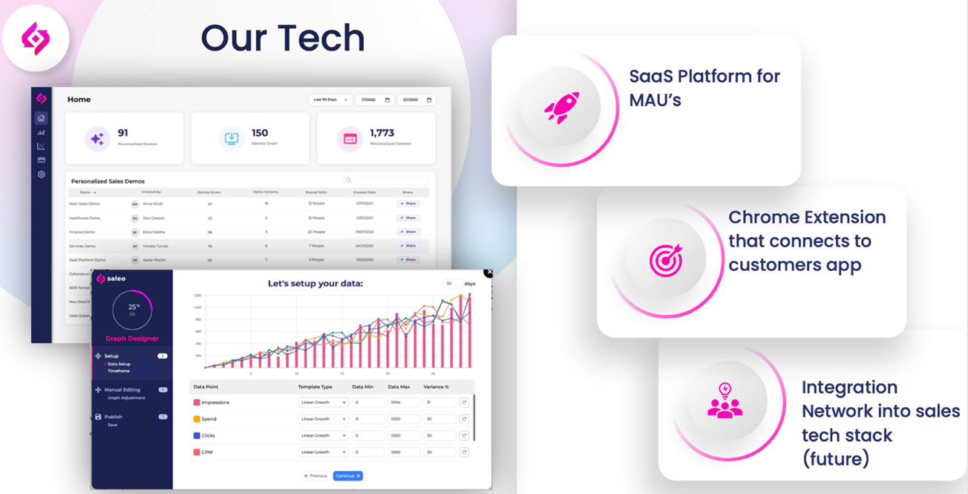

Differentiation: 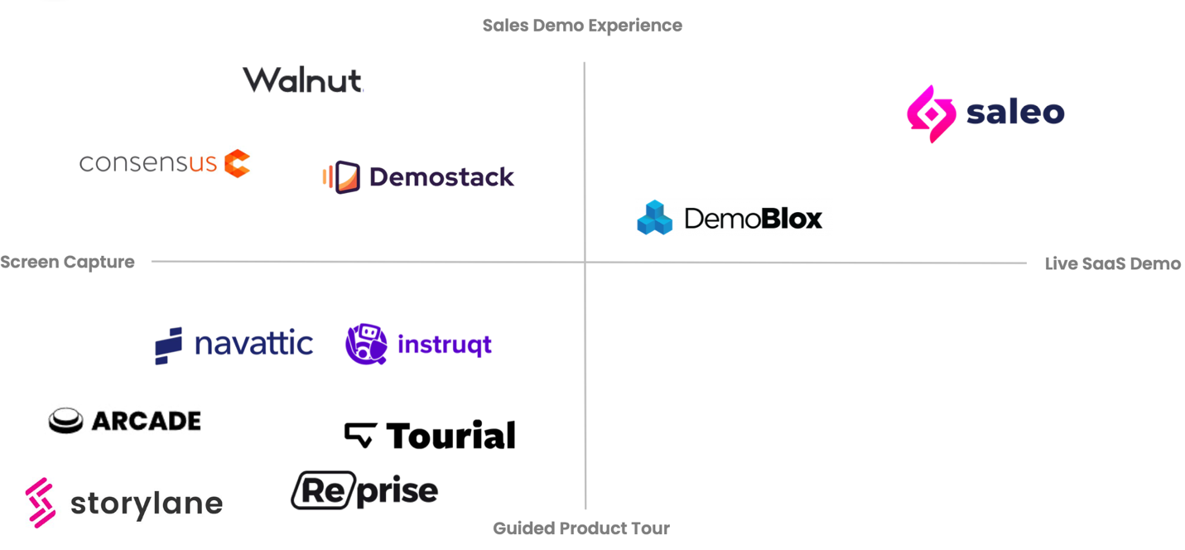
- Tourial uses screenshots, gifs, and animations as the foundation for their tours. Much weaker demo experience, but enables them to build product content outside of SaaS (hypothetically).
- Navattic, and Reprise copy the DOM, using a Chrome extension, and replicate the front-end code from the website into a demo environment. Still a sandbox, with limited interaction, and no way to customize demos in real-time.
- Saleo intercepts the data requests, enabling a live demo environment in the native SaaS product, but with customized manipulations.

End User and Customer Profile:
Buyer Personas:
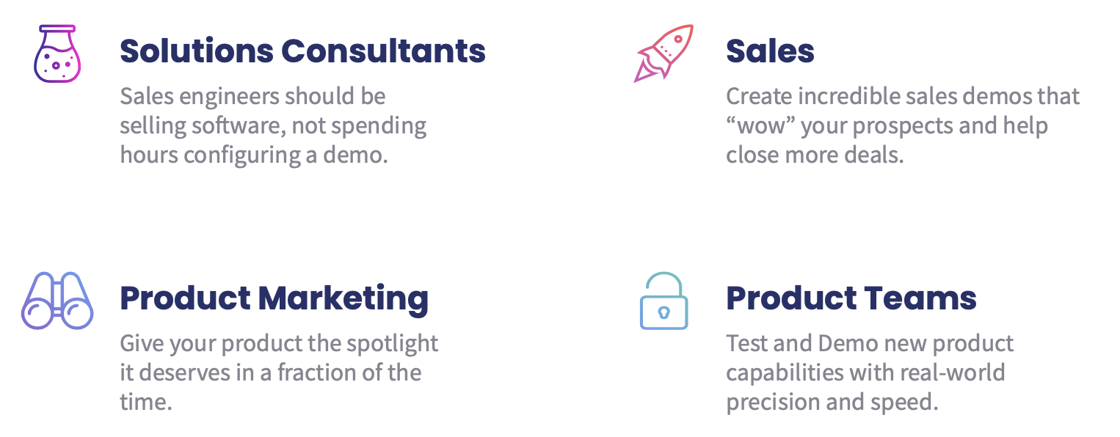
Target segments:
- Tech native SaaS companies
- Less tech savvy companies, with SaaS products
- Software products within enterprise
  - Biggest pain points are ideally products with lots of data, dynamic to time period, and dependent on each other (i.e. showing Revenue and Revenue Multiples, one changes the other.

Market Calls:

Live Demo –
Nick Belenky (Vasant) https://www.linkedin.com/in/nickbelenky/
Sales executive at Black Knight (NYSE: BKI), a $1.5BN revenue software company. Previously CRO at Top of Mind Networks, a real estate software company acquired in 2021 for $250 million. Sales engineer by training
- (+) By intercepting endpoints, less security issues and scalable across instances vs implementing or embedding into product (Pixel, etc…)
- (+) Most excited about using the tool to close more demos. Revenue based ROI much easier to get budget for
- (+) But also sees savings on SEs, can go longer without them. Or may not need them at all. You can basically enable sales people to give demos like a sales engineer (SE is 2-4X cost of sales person)
- (+) Can you actually improve demo win rates? Yes, if you can do:
  - Playing up the empty data scenario vs post-sales (using weak data or stills). Visceral alternatives
  - Industry specific demos. Like an EDI solution, worked for healthcare and commercial rail
- ( - ) Original use case (cost) was not as compelling for him - that was what we spent most time on - did not seem as much of a pain point
- ( - ) Chrome extension is very tough to get for super large enterprise - they would probably not use it at BKI
- ( - ) Measurement tools are not as relevant (mainly for larger customers)
  - Chorus and Gong are doing coaching, breaking it down by who's talking, but don't know what part of the product you're in, for how long, etc. great exit opportunities.
  - Does more to help form the GTM motion and story, than it does to optimize it (thinks Gong is more valuable).

Shannon Bauman and Dan Bonnet (Cloverly)
- Shannon sat in on demo of Tourial and Saleo, feels Saleo really solves a problem, product is significantly better. Dan was less excited about the product from a pain point perspective (and had used Tourial before, albeit at a much smaller price point)
- Shannon questioned whether implementation and onboarding was still manual on the Saleo side, and how scalable that was (getting to an automated product)
- Cloverly is currently considering building their demo environment, or doing this instead, very timely. Evaluating Demostack and Saleo, as best of all the competitors so far, but Saleo price point unlikely to work, will have to be much lower (Justin had pitched aggressively at $50k)

Jeff Wilson (Prior CRO at Verusen, re: Saleo)
- Knew Tourial from before, and currently uses Reprise. Was interesting in this market and doing demos better
- If they can take the company’s own data and dynamically serve it in its environment without needing to use Reprise templates or development resources, “that would be like the holy grail”
- However, they were paying $18k annually for Reprise (vs. $25k list), as a Series B company

Robert Dippell, CRO, Omeda ($25M ARR SaaS company)
- Don’t use a demo product currently, evaluating Reprise
- Don’t necessarily see the need - uses screen capture and slides, primarily, and don’t see the value in automating demo creation - “we are low volume high ACV so we custom all our demos meaningfully, and don’t see that changing”

Tonni Bennet (Twilio)
- Tailored Demos are very difficult, huge pain point to demo in general for an API infrastructure product
- Data stories would be very valuable, if dynamic to the customer persona. Twilio has so many applications
- Dan is brilliant, but a ‘wild-card’. Needs to be paired with ‘someone like her’, which I think Justin is for the most part.

Andy Zalasch (Terzo, previously IBM and Oracle)
- Wouldn’t see as much value for Terzo, as they hop into the platform as is and generally don’t see as much value in customizing by industry
- Don’t want the demo to be too good for Terzo, b/c they are trying to get them into POC
- For IBM and Oracle though, custom demos were a must and they deployed a ton of dev resources for it
- Demo-level analytics would be super valuable for large enterprise, given all the silo’s of sales teams and products

Pricing / Business Model:

Pricing is still in flux as they are just entering the market. Our market calls have suggested anywhere from $10-20k ACV on the very low end, to $60k+ on the high end. However, the team claims that Terminus spends $120k on their current software that they do not like, and they have talked to others who spend $60k on software and $60k on services. Terminus has committed to a $60k license once available (verbal). Companies the size of Salesloft reportedly spend over $1M+ in dev resources and solutions architects to produce custom demos.
The company is deciding between pricing tiers based on seat count & employee size vs demo count & usage. Generally looking at $30k 🡪 $60k 🡪 $90k

Market:
TAM: We used 4 sources and landed on Crunchbase and Pitchbook as most accurate, but generally used SaaS + Cloud + Software + IT industries, multiplied by pricing based on employee count (size).
This results in a $1.5-$4bn global TAM.
SAM: Given Saleo’s products relies on a Chrome extension, swapping data in real-time based on cloud interfaces, and is strongest with data presentation, we limited the SAM to SaaS + Software.
This results in a ~$1bn global SAM.
SOM: Ultimately, SaaS is the current target persona and most likely to benefit from Saleo. This is a smaller market today, ~15k SaaS companies in the US and ~25k globally.
This results in a ~$160M global SOM.
However, this is a fast growing market and the global SOM is expected to double over $300M by 2026 (at 15% CAGR)
Growth: Across multiple sources, the SaaS / Cloud software market (by spending and # of vendors) is growing 15-20% CAGR.
Market Sizing

Competition:

Competitor | Date Recently Raised | Amount Raised / Total Raised | Lead Investor | Differentiation
Walnut | 12/2020  08/2021  01/2022 | $6.0 M- Seed  $15.0 M- Series A  $35.0 M- Series B  Total = $56.0 M | NFX  Eight Roads Ventures  Felicis Ventures | The company's platform runs product demos as a live experience even when the actual product is offline or in development without relying on back-end assistance, thereby enabling the sales team to customize demos before each meeting
Reprise | 11/2020  02/2021  11/2021 | $3.2 M- Seed  $17.0 M- Series A  $62.0 M- Series B  Total= $82.2 M | Accomplice/GlassWing Ventures  Bain Capital Ventures  ICONIQ Growth | Platform creates locked demos through capture of the DOM and front end code for web-based SaaS Products. Allows for same front-end functionality but in closed environment.
Demostack | 12/2020  03/2021 | $4.0 M- Seed  $13.5 M- Series A  Total= $17.5 M | Amiti Ventures  Bessemer Venture Partners | harp no-code, stress moreso sales use cases, but ultimately don’t see much in the way of differentiation
Navattic | 01/2021  05/2021  03/2022 | $.1 M- Pre Seed  $1.2 M- Seed  $4.2 M- Seed  Total= $5.5 M | Y Combinator  645 Ventures  Canvas Ventures | Starkly similar to Walnut and Reprise

Capital Raise and Milestones:
Milestones and Model: Looking at $1.5-$2M raise to take business to $1.9M in ARR in 12 months
Founders model and assumptions:
- 1 to 38 customers in year 1, on $35k ACV, to reach $1.9M ARR in 12 months
- Q1 founder selling, Q2 - 1 AE and 2 SDRs, phases into 2 AEs up ramp by Q4
- With $1.5M - runway through 18 months on that ramp
Alternate case with tempered growth:
- 1 to 29 customers in year 1, slightly lower $25k ACV, to reach $1.2M ARR in 12 months
- Delayed a few hires to match difficulty of finding them quickly, needs at ARR (i.e. SVP of engineering, 2nd AE, etc…)
- With $1.5M - still plenty of runway to cross 12 month mark, compelling ARR and 15-20% growth to raise next round at 2X last round.
- Will be burning $150k / month at end of year 1, reasonable

Valuation: (Valuation Analysis)

Method 1: Dilution & Cash Needs
- Unfortunately few relevant comps with early stage rounds. Looking at Pendo, WalkMe, Spekit, Walnut, and others, they range widely from 20% to 30% generally. However, current market dynamics are pushing raises toward the lower end of that range. This is also pre-seed, which tends to be lower.
- Using the $1.5M assumption, and an aggressive 15-18% dilution, that results in a post-money valuation of $8-10M

Method 2: Venture Method / PWAR
- The below assumptions …
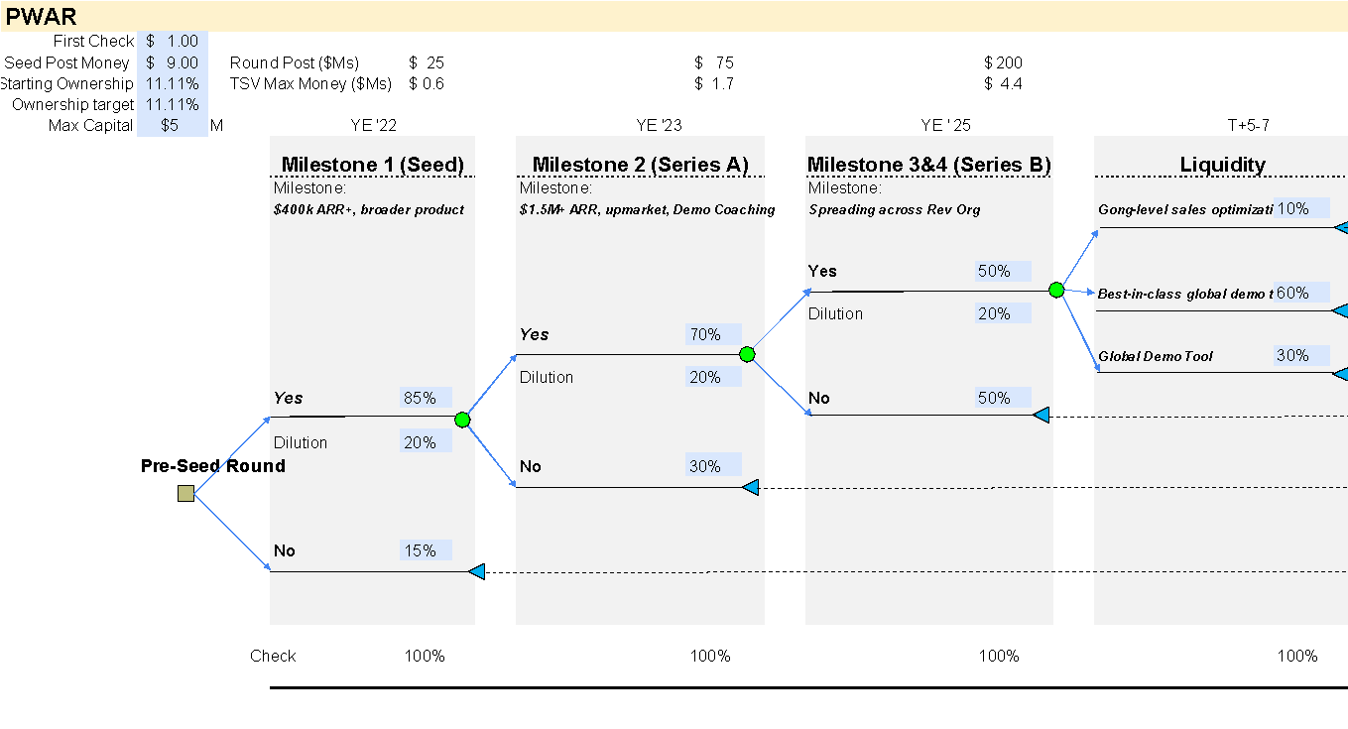

Resulted in the following PWAR: …
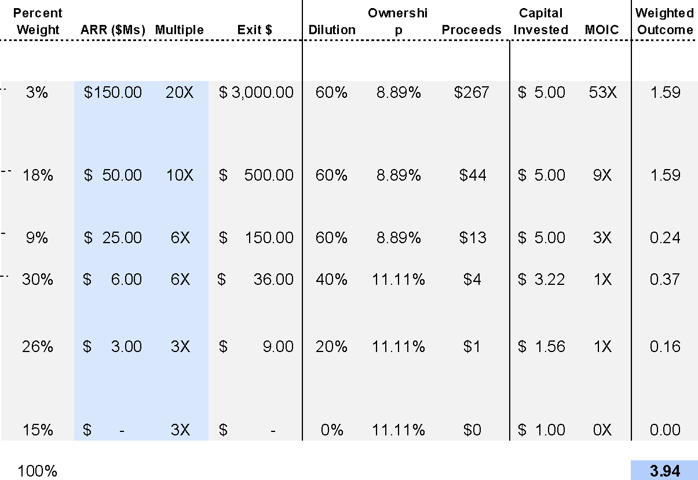
- Generally higher probabilities of sub-$100M exits, with typical upper end probabilities, however with the high end sustaining $3bn, given overall concern of the market size. $9M post results in 11.11% ownership and adds .5X to the overall PWAR (MOIC in blue). A meaningful sticking point.
Appendix

Pitch Deck
Financial Model (TSV Edit)
Pipeline 1-pager
Market sizing

